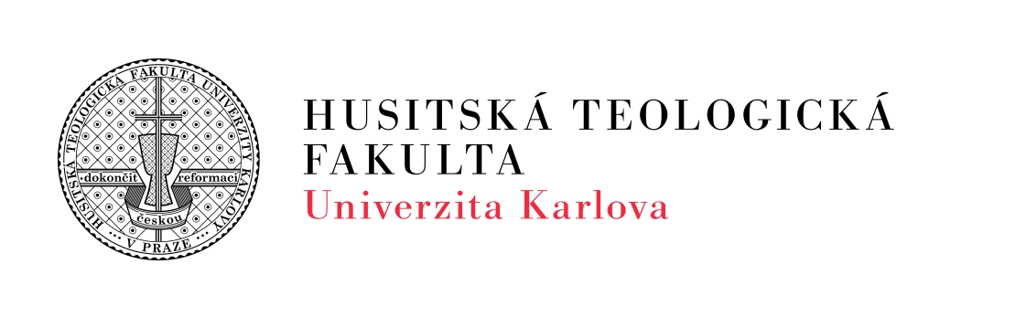

Ref. No.: UKHTF/569018/2026

Selection Procedure for the Position of Academic Staff Member
Department of Teacher Education – Assistant Professor
The Dean of the Hussite Theological Faculty of Charles University hereby announces, in accordance with the Charles University Rules of the Selection Procedure, as amended, a selection procedure for the position of Assistant Professor at the Department of Teacher Education.
Requirements:
- Completed doctoral degree (Ph.D. or equivalent) in the relevant field of security and legal studies.
- Continuous publication record and other scholarly and creative activities in the field Social Sciences.
- Experience in research projects and grant-funded activities.
- Academic experience in the field of Social Sciences.
- Ability to teach courses within the study programme of Education.
- Excellent knowledge of the education system, supported by extensive teaching experience at the lower secondary or upper secondary level, particularly in the areas of Civic Education and Social Sciences.
- Excellent understanding of current social issues relevant to the fields of social pedagogy and the prevention of socially risky behaviour.*
- Extensive university-level teaching experience in sociology and social pedagogy, including the supervision and assessment of Bachelor's and Master's theses in these disciplines, together with a thorough knowledge of social science research methodology.
- Demonstrated experience in preparing grant applications and leading research and development projects funded through competitive grant schemes.
- Good command of the English language.
- Native-level proficiency in the Czech language.
- Ongoing scholarly publication, other creative activities, and further academic qualification development are expected.
General Information:
- Expected starting date: September 2026
- Workload: 0.6 FTE
- Salary: AP2 monthly salary grade - 39 000 CZK (in accordance with the internal regulations of Charles University)
Required Application Documents:
- Written application.
- Cover letter.
- Structured curriculum vitae, including an overview of previous professional experience.
- Certified copies of university diplomas and other documents proving the completion of higher education and the award of academic degrees.
Application Deadline and Submission:
Applications must be submitted by 31 August 2026, either:
- electronically by e-mail to silvie.dratvova@htf.cuni.cz (subject line: Application for the Selection Procedure), or
- in hard copy by post or delivered in person to:
Hussite Theological Faculty, Charles University
Mgr. Silvie Dratvová – Dean's Office Secretariat, Pacovská 350/4, 140 21 Prague 4 – Krč, Czech Republic
The Faculty reserves the right not to fill the position.
Published: 1 August 2026

doc. ThDr. Jiří Vogel, Th.D.
Dean

Informace o zpracování a ochraně osobních údajů na Univerzitě Karlově:
https://cuni.cz/UK-9056.html

