Primus – manual for applicants

1. Access to the application
Submitting a competition proposal is possible using the application http://veda.is.cuni.cz
(We recommend using recent version of Chrome or Mozilla Firefox.)
CUNI employees and students:
for logging in, use your personal identification number, which you will find below the photograph on your CUNI ID card and the password from the CUNI Central Authentication Service: http://cas.cuni.cz
Applicants from outside CUNI:
to acquire login data, register using a form at http://veda.is.cuni.cz/primus

Registration of applicants from outside Charles University
The registration form for access to the system for submitting applications is available at http://veda.is.cuni.cz/primus
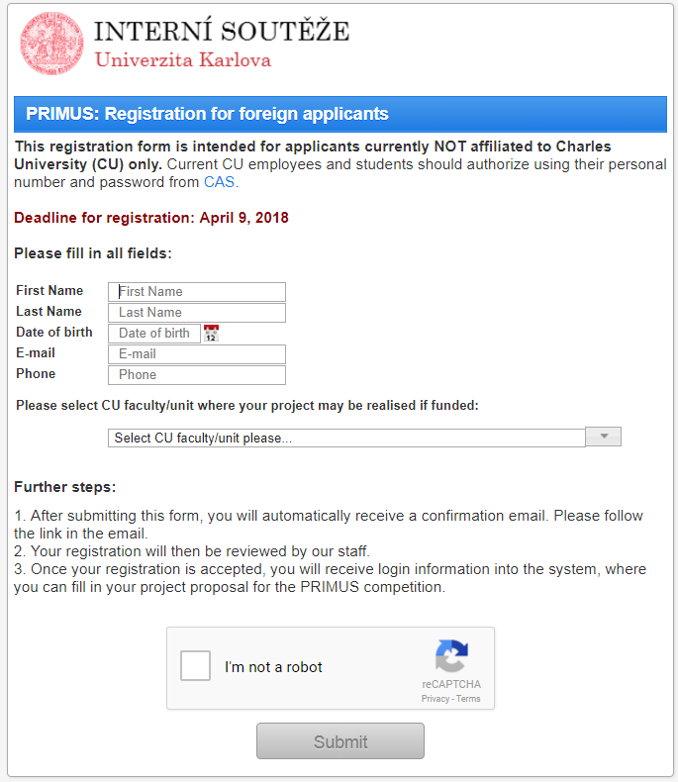
- After you fill in all information and submit the form, you will receive a confirmation email containing a link. Clicking this link (or copying it to the browser address bar), will verify your email address.
- Your registration will be then checked by the staff of the CUNI Rector’s office, and within a few work days you will receive an email with your login details.

After logging in, information about the Primus competition appears with a Go to the list of my applications button to take you to ´My proposals´ page
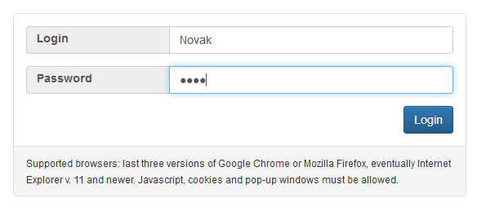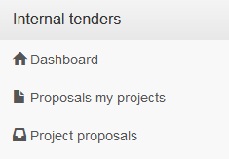

2. Creating your proposal
If this is the first time you have entered the system or if you have not started to prepare a proposal, click the New proposal (in the Project proposals) button. Otherwise do not create a new proposal and open a proposal already created by clicking the name or number of the proposal and go straight to Chapter 3.

2.1 Selecting a category
When setting up a new proposal, first select the relevant competition category:
PRIMUS HUM | Humanities and Social Sciences
PRIMUS SCI | Sciences, Mathematics and Informatics
PRIMUS MED | Medical sciences and Biomedicine

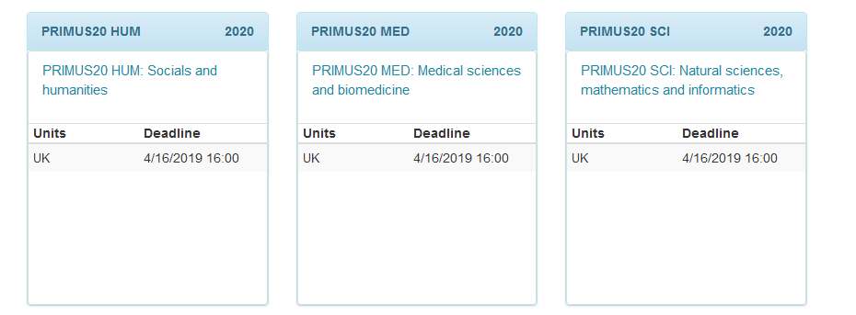

Each proposal must be assigned to one of the categories. Please explain any interdisciplinary ties in the project description.

2.2 Creating a proposal
After selecting a category (by clicking its name), you can read the competition call (you can return to this any time later by clicking the Competition call button, which will appear on the proposal form above on the right and offer for downloading the recommended CV template). Then click the Create proposal button. During the first step, fill in all the form's fields.

Project title in Czech and Project title in English OBLIGATORY, 120 characters for each language (incl. spaces)
The project name should not include abbreviations and must not exceed 120 characters including spaces.

Faculty/institute OBLIGATORY
If this field is not filled in automatically on the basis of your personal details, select from the code list of the faculty or university institute where the project will be conducted.

Commencement of the project OBLIGATORY

Termination of the project OBLIGATORY
The implementation of an approved project must start earliest 1st January and latest 1st September of the year following the year of application. The maximum duration of each project is three years. Prolongation by additional two years shall be considered in case the projects are being rated as excellent by the evaluation board.
Please fill in the dates.
Then click the Create project button, by which the form of the project will be created, and you can continue editing it.

3. Editing your proposal
Please fill in the details in individual tabs and regularly save the information by clicking the Save changes button (bottom right). You can always return to the saved unfinished proposal.

3.1 Basic information
In the first tab, describe the basic idea of the scientific plan submitted.
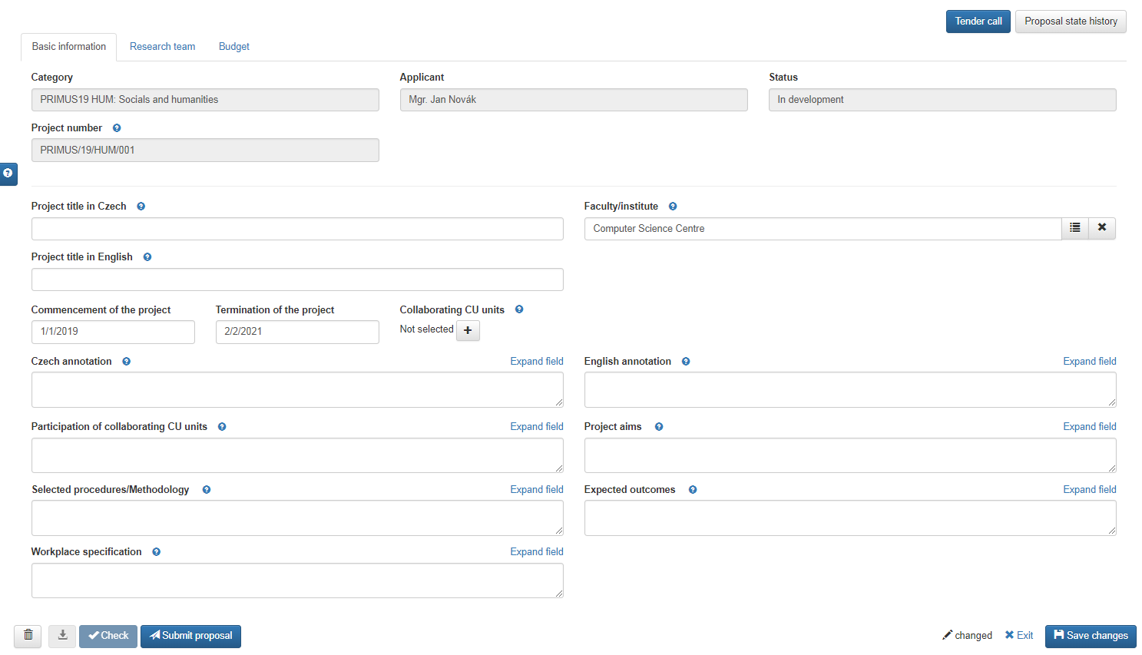

Czech annotation and English annotation OBLIGATORY, max. 1,200 characters for each language
Give a brief annotation of the project in Czech and in English. The text of the annotation will be used to present the Primus competition and the individual projects.

Collaborating CUNI units OPTIONAL

Participation of collaborating CUNI units OPTIONAL, max. 900 characters
If other faculties/institutes are expected to participate on the project, please specify them together with a brief description of the scope of their participation.Please state any financial contributions made by the faculty/university institute in the comment.

Project aims OBLIGATORY, max. 900 characters
Identify the main aims/objectives of the project and describe the project outline. Justify his contribution to the national and international context.

Selected procedures/Methodology OBLIGATORY, max. 3000 characters
Describe new conceptual and methodological procedures or their connection to well recognized international results.

Expected outcomes OBLIGATORY, max. 3000 characters
What results are expected during the project and on its completion (eg. journals articles, monographs, patents, etc.) or other possible implementations?

Workplace specification OBLIGATORY, max. 1000 characters
Is your organization able to support you with relevant equipment/ facility needed for the project? If the project requires a purchase of a new device, etc. please specify this information in the budget statement.

3.2 Project team
The minimal size of the team should correspond with the specifics of the research area. However,the project team must include three doctoral students and/or postdoctoral fellows in addition to the principal investigator (see below) by 31st December (of the year following to the application) the latest. There is no maximum limit of the research group size given, the PI decides on such limit.
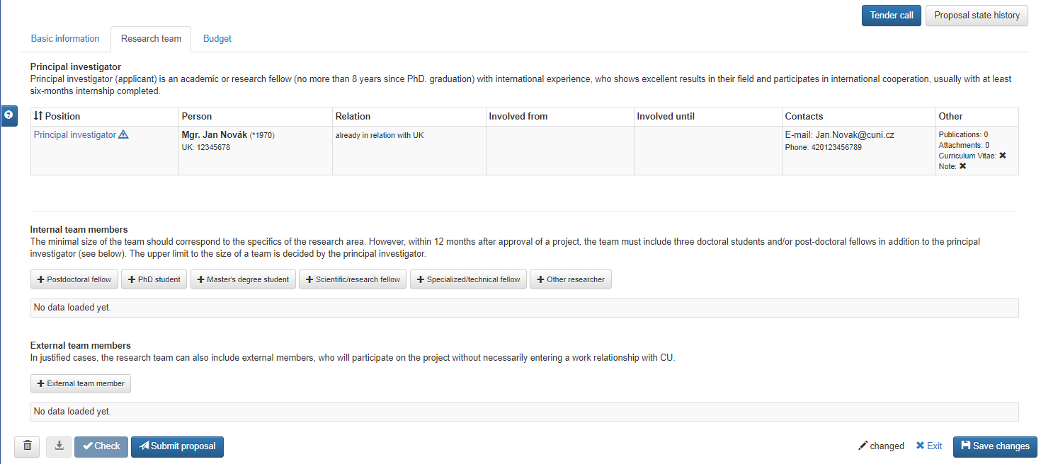

3.2.1 Principal Investigator (PI)
It is expected that the applicant is also the principal investigator (PI). The PI of the project meets the following criteria:
- an academic or research fellow with international experience who has achieved excellent results in his/her field and takes part in international cooperation;
- he/she has attended an internship of at least 6 months or spent a significant part of his/her professional career outside of the Czech Republic;
- he/she has obtained a PhD diploma no more than 8 years prior to the submission of the proposal (this does not include documented maternal or parental leave, military service and attested long-term illness);
- at the time of submitting the proposal, he/she does not have to be an employee of the university. However, he/she must become a CUNI employee by the time the project starts with the majority of his/her working time spent at the university, its faculty hospitals or at the joint workplace of CUNI and the Academy of Sciences (work carried out in various parts of the university can be added together;
- a PI can only submit one project proposal to the Primus programme;
- he/she can be involved in other internal university programmes or competitions, but not as a PI.
It is expected that the principal investigator will apply for an ERC grant (or in case of the humanities and social sciences for another major international grant) before the project ends.

At the creation of a new proposal, the applicant is automatically inscribed as the project's PI. However, additional data must be filled in. You can edit each person’s details by clicking the name of the position (Principal investigator).

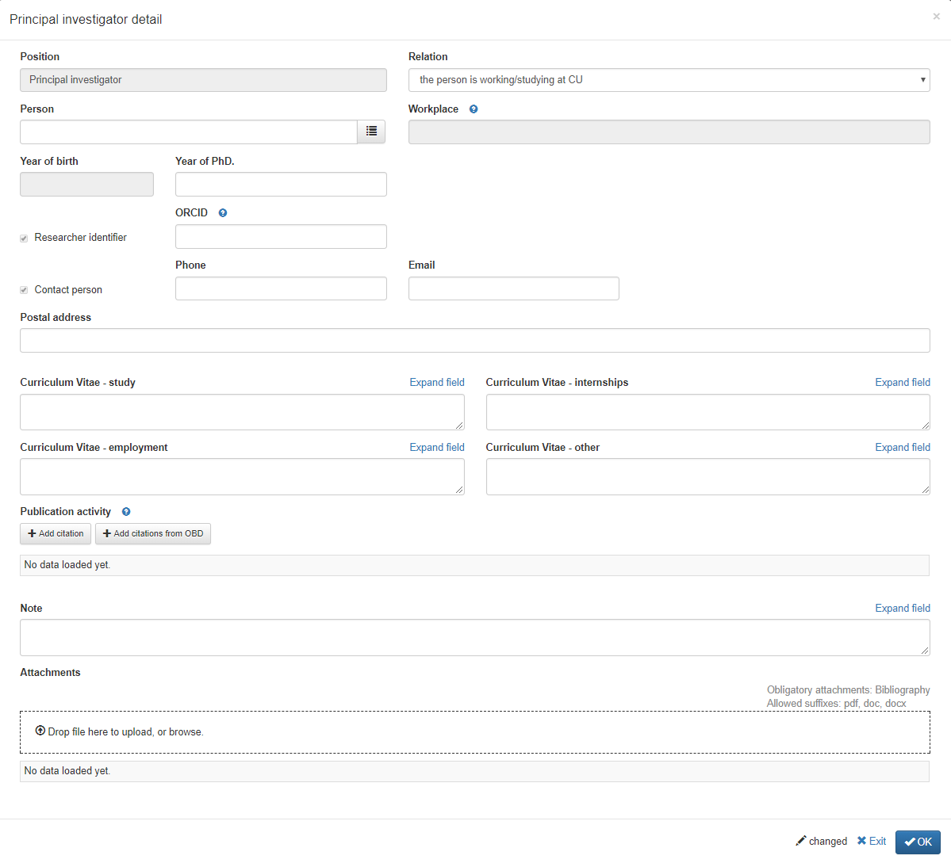

Relationship with CUNI OBLIGATORY
Choose the relevant value in the drop-down list on the right next to the position:
- the person is working/studying at CUNI
- the person will become employee of CUNI if the project receives funding

Workplace OBLIGATORY IF THE PERSON IS ALREADY AFFILIATED TO CUNI
If the workplace (or future workplace) has not been filled in automatically,
- open the list
- click the Filter button
- select the appropriate workplace
If the project is to be conducted at a workplace other than the present one, select the appropriate workplace and state this in the Notes. (Workplaces are filtered automatically according to the faculty selected in the proposal; you can alter the searched faculty by changing the setting in the drop-down menu in the upper part of the code list.)

Planned workplace OBLIGATORY IF THE PERSON IS NOT YET AFFILIATED TO CUNI
If the PI becomes CUNI employee only in case the project will receive funding, and the workplace has not been filled in automatically, select the planned workplace at which the person will be employed.

Contact person OBLIGATORY
The PI is one of the contact persons for the project. Fill in his or her email address, telephone number and post address.

ORCID OBLIGATORY
Please fill in your ORCID user ID (Open Researcher and Contributor ID). In case you do not have one, register at: https://orcid.org/

Curriculum Vitae - study OBLIGATORY

Curriculum Vitae - internships OBLIGATORY

Curriculum Vitae - employment OBLIGATORY

Curriculum Vitae - other OBLIGATORY
Provide your CV into the respective fields.

Publishing activity OBLIGATORY (3 - 5 publications)

Attachments Allowed file formats: DOC, DOCX or PDF
Insert the attachment by dragging the file into the dashed box or by clicking inside it. After choosing the file from the hard disc, choose the ‘CV’ type of attachment (see below) and save it.
To delete an erroneously added attachment, hover your cursor above the left column of the table of inserted files until the waste bin icon appears. You can then remove the attachment from the proposal by clicking this icon.

Bibliography OBLIGATORY
In the PI section, attach a file with full list of publications.

Other attachment OPTIONAL
If you need to attach a file containing full text of one of the most important publications (see above) or other scientific outputs, you can do so by attaching it as a file and specifying the “Other attachment” type of attachment.

3.2.2 Internal team members
For the purposes of the Primus programme the following internal co-researcher positions have been introduced:
- post-doctoral fellow: a scientist who has gained a PhD diploma during the last 8 years and has not been working as an assistant professor or professor yet
- PhD student: PhD student in a CUNI programme
- Master's Degree student: in a CUNI programme
- other researcher: CUNI employee or future employee working in science, research or education not covered by the given definition of a post-doctoral fellow
- scientist/researcher: employee or future employee of CUNI with a job description comprising scientific/research activities only, not fulfilling the the above definition of a post-doctoral fellow
- technician: employee or future employee of CUNI performing specialized jobs and partial conceptual or methodical work, e.g. a lab assistant, technician, etc.
You can add further team members by clicking the button with the corresponding position. Current students and employees but also expected future employees of CUNI should be listed among internal members.

Relationship with CUNI OBLIGATORY
Choose the relevant value in the drop-down list on the right next to the position:
- the person is working/studying at CUNI
- the person will become employee of CUNI if the project receives funding
- position will be assigned after the commencement of the project
By selecting the ‘position will be assigned after the commencement of the project’ option, you agree to assign a person to the given position the latest by 31st December (of the year following to the application) in the Description field, specify the presumed job description for this position.
Should the project proposal contain, for example, two positions later assigned to PhD students, enter both of them one by one and for each of them specify the presumed job description.

Person and Workplace OBLIGATORY IF THE PERSON IS ALREADY AFFILIATED TO CUNI
A person that is already an employee of CUNI must be selected from a code list for the correct workplace at which the project will be conducted. If the project is to be conducted at a workplace other than the present one, select the appropriate workplace and state this in the Notes. (Workplaces are filtered automatically according to the faculty selected in the proposal; you can alter the searched faculty by changing the setting in the drop-down menu in the upper part of the code list.)

First name, Last name and Planned workspace OBLIGATORY IF THE PERSON IS NOT YET AFFILIATED TO CUNI
If a person becomes an employee of CUNI only in case the project will receive funding, fill in the person’s name and surname and select the presumed workplace at which the person will be employed.

Contact person OPTIONAL
If the given person is one of the of the contact persons of the project, check this option and fill his/her email address and telephone number.

ORCID OBLIGATORY
Please fill in the ORCID user ID (Open Researcher and Contributor ID).

Publishing activity OPTIONAL (3 publications maximum)
It is not obligatory to specify the publishing activity of co-researchers. If, however, you wish to insert this information, proceed the same way as in the case of the PI (see above).

Attachments NOT REQUIRED
No attachments are required in the case of co-researchers.

3.2.3 External team members
In justified cases, the research team can also include external members, who will participate on the project without necessarily entering a work relationship with CUNI.

In the case of external team members, the only required details are their name, surname and main affiliation. If the workplace is not offered in the menu, please specify it in the Notes.

3.2.4 Removing an erroneously added person
If you need to remove a person added to the project, hover your cursor above the name of the person’s position (in the left column of the table), until the rubbish bin appears. Clicking this icon will remove the person.
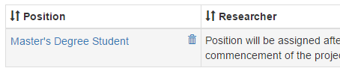

3.3 Project budget (both parts of budget)
The funding of Primus projects is governed by the following basic rules:
- Projects are co-financed equally by the university and faculty.
- Projects are financed from the university’s resources by the same amount as that by the supporting faculties / institutes of higher education, but only up to the amount of CZK 1.5 million/year by the university.
- Later transfers between non-investment and investment resources are possible only with the approval of the Economic department of CUNI Rector’s office
- The funding provided cannot be used to pay administrative staff.
- Resources allocated to scholarships/personnel costs cannot be used to pay for travel expenses.
- Resources allocated for the acquisition of long-term property cannot be used to finance write-offs.
- The maximum general and administrative expenses received equal the maximum of 15% of the sum of non-investment resources (this condition applies separately to means provided by the university and those provided by the faculty/university institute).
- CUNI reserves the right to amend/cut the structure and the total sum total of allocated resources

3.3.1 Budget for the first year of the project
Provide an itemized budget of the project in a round amount of CZK for the first year of the project:
- personnel costs (salaries incl. obligatory social and health insurance, work contracts (such as ”Dohody o pracovní činnosti“ and/or “Dohody o provedení práce“), other personnel costs/remunerations, scholarships)
- operational costs, travel expenses and services
- costs of long-term acquisitions (investments)
- general and administrative costs/overheads
Enter the requested sum by clicking the name of the item.

3.3.2 Annual costs for the following years of the project
For the remaining years of the project, please provide only the total expected sum of annual costs of the project in a round number of CZK (which you can enter after clicking the ‘Annual total…’ link).
The total sum requested will be summed up automatically and displayed in the top field as you edit each item.

3.3.3 Budget justification
In the Budget justification field, provide a brief justification for each requested item in the requested budget (max. 3 000 characters including spaces).

4. Checking and submitting your proposal

4.1 Formal check
While working on your proposal, you can at any time check whether all required fields are filled in and that other formal requirements are met by clicking the Check button at the bottom left. This button becomes enabled after the proposal has been saved using the Save changes button.
This check is, of course, carried out automatically also before the final proposal is submitted.

4.2 Submitting your proposal
To submit your finished proposal, click on the Submit proposal button (bottom left).
The system check whether all required fields are filled in and all of other formal requirements are met, and display the result; if it detects an error, the Submit proposal will reappear. After this button is pressed a second time, the proposal gets submitted, and you will no longer be able to edit its content.

5. Exporting your proposal
After clicking the Export button the PDF file with your proposal will start to download.

6. Do you need help?
Use the blue question sign button, which you can find on the left side of most pages, and send us your question using our Helpdesk. You will receive an answer to your question via email within a few working days.

7. Changing your password (only for users outside the CUNI Authentication System/CAS)
Users that log in using a different password than their CAS password can change this password by clicking their name in the top right corner and selecting the Account settings option.

8. Logging out
To log out, please click your name in the top right corner and select the Logout option. To log out fully, you will have to close the browser window.

